**Smart Tech Solution Pvt. Ltd.**

Thapagaun, New Baneshwor

Kathmandu, Nepal

+977 - 01 - 5245027

**User Manual**

**For**

**Asset Management Web Configuration Panel**

1. Background 4

1.1 Assets 4

1.2. Maintenance 4

1.3. Service level 4

1.4. Asset Management 4

2. Asset Management Plan 4

3. Introduction 5

4. The Configuration Panel 6

a. Home 6

b. Finance 6

c. Maintenance 7

5. Using the Web Configuration Panel 8

5.1 Home 8

5.1.1 Add/Edit General Information 9

5.1.2 Add/Edit Mobile App Users 10

5.1.3 Add/Edit Beneficiary Information 11

5.1.4 Tariff Rates 12

5.1.5 Add/ Edit Water Supply Schedule 12

5.1.6 Allow changes in the cashbook via the app after the month is closed 13

5.2 Finance 14

5.2.1 Expected Income- Water Tariffs 14

5.2.1.1 Add/Edit Expected Income-Water Tariffs 14

5.2.1.2 Add/Edit Expected Income-Water Tariffs 16

**`5.2.1.3 How EPC is calculated?** 18

5.2.2 Expected Income/Expenditure (Other) 21

5.2.3 Inflation Rate(%) 24

5.2.4 Actual Income/Expenditure (Cash Book) 24

5.2.3.1 Manage Income Categories 25

5.2.3.2 Manage Expenditure Categories 26

5.2.3.3 Add/Edit Income 27

5.2.3.4 Add/Edit Expenditure 28

5.3 Maintenance 29

5.3.1 Asset Inventory 30

5.3.1.1 Add/Edit Asset Inventory (Component Categories) 30

5.3.1.2 Add/ Edit Component 30

5.3.2 Expected risks, activities & Cost 31

5.3.2.1 Add/Edit Component Info 31

5.3.2.2 Add/ Edit Issue (Logs) 32

5.3.2.3 Add/ Edit Actual Maintenance Logs 33

5.4 Service 34

5.4.1 Water Supply Records 35

5.4.1.1 Add/ Edit Water Supply Record 35

5.4.2 Water Quality Test 35

5.4.2.1 Add/ Edit Quality Test Parameter 36

5.4.2.2 Add/ Edit Water Test Results 36

5.5 Notifications 37

5.5.1 Manage Notifications 37

5.6 Change Language 38

5.7 Logout 39

# 

# 1. Background

The asset management tools comprising a mobile app, a web dashboard, and a configuration panel are developed to support the management of assets and making asset management plans for water systems. To completely understand the concepts of asset management and the use of these tools, there is an entire e-learning platform that can be accessed at the following URL. <https://elearning.assetmgmttool.com/>

Following is a brief introduction to important concepts of asset management to help users understand different features of the tools while going through this manual.

## 1.1 Assets

An asset is a useful object or one of its components that is expected to provide benefits to the user, a person, or a company. For water systems, assets are the physical components of the system that allow for reliable, and safe water supply to the users. For example, wells, filtration units such as chlorination tanks, sedimentation tanks, roughing filters, hydrants, pipes, valves, bolts, overhead tanks, pumps, and household taps with meters.

## 1.2. Maintenance

Maintenance is the activity to ensure that assets keep on fulfilling their intended function during their full lifetime. Maintenance is important to reduce the risk of failure, ensure the system is reliable, and (in the case of water systems) provide clean water continuously to end-users.

## 1.3. Service level

The service level (SL) of a water system is the agreed quantity and quality of water supply during a certain time.

## 1.4. Asset Management

Asset management is the activity of maintaining the agreed service level during a sustained period of time at a certain cost.

# 2. Asset Management Plan

An Asset Management Plan is developed applying a community-led approach and supports stakeholders to ensure the required service level during a period of time. It includes:

1. An asset inventory

2. A risk assessment

3. A maintenance plan

4. An income and optimization analysis: A financial projection of what income (= water tariff and extra-governmental or charity contributions) is required to cover the costs for the agreed SL.

An Asset Management plan needs to be updated regularly since financial projections might not match reality, or some maintenance might be unforeseen and not included in the plan and cost estimates.

# 3. Introduction

Asset management tools for individual water system includes the following,

1. A mobile app

2. A web dashboard

3. A configuration panel

The mobile app is a password-protected application that allows operational staff members of the water system to view and add information about the water system. The web dashboard is a publicly accessible web link that presents information about the water system. The configuration panel is the password-protected data management area for the entire system. Data and settings for the water system can be managed from the configuration area.

When a new water system is added, a web dashboard link and a user for configuration panel is created. Users for mobile applications can be then created from the configuration panel.

The entire tool set focuses on 3 major areas of asset management for water systems, finance, maintenance, and service.

The configuration panel is used to manage general information about the water system, expected and actual income and expenditure, asset components with lifespan, risks and costs, and quality test parameters. The mobile app lets staff members fill in actual monthly transactions, view a list of asset components for maintenance and fill in maintenance logs, add water supply records and add water test results. The web dashboard combines data from both the configuration panel and the mobile app to present a visualization of finance, maintenance, and service of the water system. Some water systems’ data can be entered from both the mobile app and the configuration panel. This gives more flexibility.

# 

# 4. The Configuration Panel

This manual guides users to use the configuration panel of the asset management tools. The configuration panel is the password-protected data management area for the entire system.

Login URL for the configuration panel:  
<https://assetmanagementsystem.netlify.app/#/auth/home>

***Note****: In case of lost username and password for the configuration panel, please contact the corresponding administrator agency who have provided the login details previously.*

The configuration panel has five major categories: 1) home, 2) finance, 3) maintenance, 4) service: water quality and quantity, and 5) notifications. A detailed explanation of each function under each category is presented in the corresponding sections of this manual. A basic overview of functions under each section is as follows:

## Home

The Home section lets users view and manage the following data:

i. General information about the water system.

ii. Information about the beneficiaries of the water system.

iii. Mobile app users of the water system.

iv. Supply schedule of the water system.

## Finance

Finance has four subsections: i) expected income – water tariff, ii) expected income/expenditures (other), iii) expected inflation, iv) actual income/expenditure (cashbook)

i. Expected income – water tariff

Users can manage information about the type of tariff (fixed or use-based) to be applied to the water system. Users can manage the tariff rates, which may be applicable at different dates and get visual estimation of the yearly and all-time income.

ii. Expected income/expenditure (other)

Users can manage other expected income and expenditure of the water system. These expected income and expenditure may be applicable at or from different dates.

iii. Expected inflation

Users can set the expected inflation rate for the period of financial analysis.

iv. Actual income/expenditure (cashbook)

Users can view and manage all actual transactions of the water system.

Note: The cashbook transactions are expected to be added from the mobile application. However, the functionality to add and manage transactions is also present in the configuration panel so that the administrator can manage entries if needed.

## Maintenance

Maintenance has three sub-sections: i) asset inventory, ii) expected risk, activities and cost, iii) actual maintenance (logs)

i. Asset Inventory

Users can manage the inventory of asset components under different categories.

ii. Expected risks, activities and cost

Users can manage expected risks, costs and maintenance parameters for each asset component.

iii. Actual maintenance (logs)

Users can manage actual maintenance logs for the water system.

Most of the maintenance is pre-scheduled and can also be logged during inspections and preventive activities. The configuration panel also allows for entering non-scheduled maintenance.

Note: The maintenance logs are expected to be added from the mobile application. However, the functionality to add and manage logs is also present in the configuration panel so that the administrator can manage entries if needed.

**Service**

Service has two sub-sections:

i. Water supply record

Users can define total water supply from a distribution point at a specific date.

ii. Water quality test

Users need to define the parameters that will be tested for the quality of water, this can only be done in the configuration panel. Mobile app users and configuration panel users will be able to fill in records for the previously defined parameters.

1. **Notifications**

i. Users can set time intervals to receive notifications on their mobile application. These intervals can be set for all input activities available on the mobile application.

# 

# 5. Using the Web Configuration Panel

When a Water System’s User logs onto the web application, the Configuration Panel is the first screen he/she will see.

## 5.1 Home

In the home tab of the configuration panel, users can add General Information, Beneficiary details, Water Supply Schedule, Disallow app editing after month closing, and add Mobile App users of the Water System. Users can also see the tariff rates, based on the Use Based and Fixed Based option.

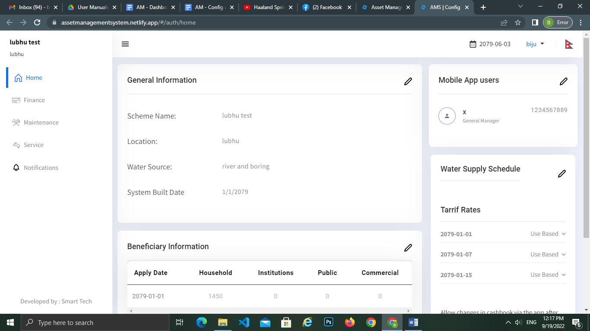

### 5.1.1 Add/Edit General Information

Users can add the General information of the Water Scheme by clicking on the edit icon placed in the right corner of the content.

Then a pop-up form is displayed where the following details have to be filled up:

1. Scheme Name: Add the Name of the Water System
2. Location: Add the location & address of the Water System
3. Water Source: Add source of water e.g. Boring water, Spring water, etc
4. Daily Target: Add total water supply (in Liters) per day. It doesn’t affect any data projection displayed in Dashboard.
5. Visualize data for (Year): Add the period (number of years) for which the data will be projected.
6. Currency: Add the unit of currency to be used
7. System Date Format: Select the format and month names to display with Visualization. Current options are EN for English and NP for Nepali. The date format can be changed later as per requirements.
8. System Built Date: Add a calendar date on which the water system was built
9. Longitude: Add Longitude to identify the location of the water system (optionally).
10. Latitude: Add Latitude to identify the location of the water system(optionally).
11. Tool Start Date: Add the calendar date on which this tool is initiated for this water system. All projections and records start on this date.

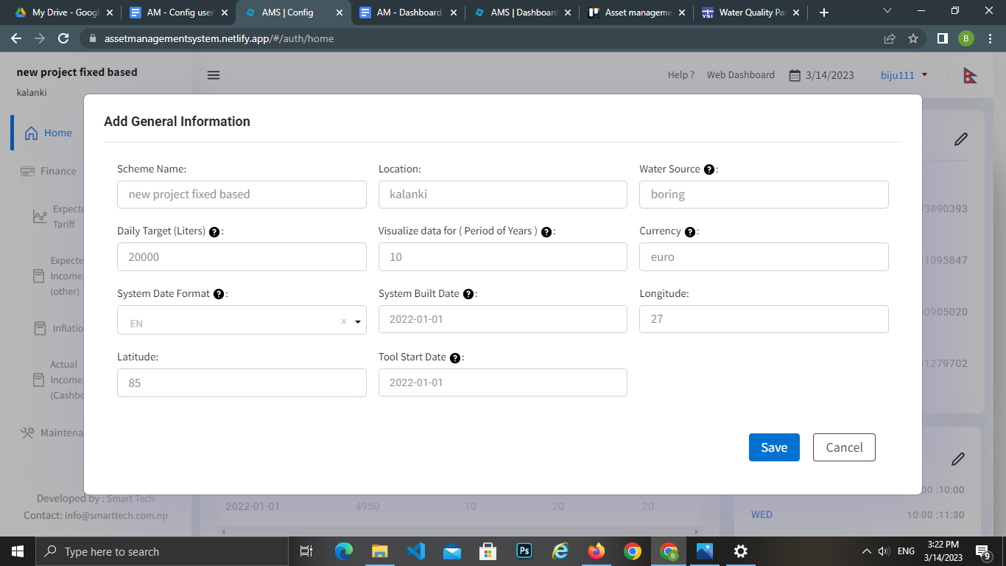

### 5.1.2 Add/Edit Mobile App Users

**Mobile App Users are those users who will get access to use the mobile app of AMS. All the Mobile App Users will get the same app with the same authorities over the app.**

After adding General information, the User has to click on the pencil icon next to the title ‘Mobile App Users’ where a pop-up form will be displayed. In order to add the Mobile App Users, the following details have to be filled in :

1. Name: Add the name of the mobile app user
2. Phone: Add the Ten Digit phone number of the mobile App User. In case the mobile App User has a Eleven Digit phone number, omit the zero (0). Also fictive Ten Digit mobile phone numbers can be used.
3. Password (PIN): Add a password of at least four digits. Alpha characters and special characters cannot be applied in this field.
4. Re-enter Password (PIN) for confirmation: Add the same Password (PIN) for confirmation.
5. Save the added data by clicking on the Save Button
6. In case of a lost password, app users can contact their configuration panel admin to reset their password.

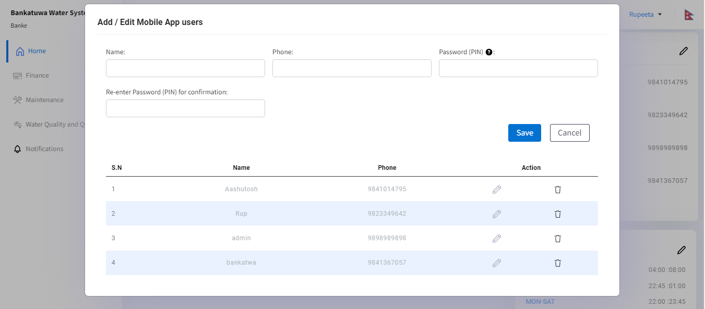

### 5.1.3 Add/Edit Beneficiary Information

In order to add and edit Beneficiary Information of the Water System, the User needs to click on the pencil icon next to the title ‘Beneficiary information’. A pop up form will appear in which the following details have to be filled in:

1. Institutional Connection: Add the number of the institutional connections ( Connections like schools, colleges, offices, etc.)
2. Commercial Connection: Add the number of the commercial connections ( Connections for commercial purposes)
3. Household Connection: Add the number of total households connection ( private household connections)
4. Public Connection: Add the number of public connections ( Connections in public places like temples, parks, etc.)
5. Apply Date: Add the date from which this record should be applied to the system.
6. Save the added data by clicking on the Save Button

Beneficiary information can change over time, e.g. when the water systems’ network is expanded to serve more customers. Beneficiary information for different time periods can be added by using different ‘Apply dates’ in the configuration panel. The User should make an extra entry under Beneficiary Information with a different ‘Apply date’ than before. .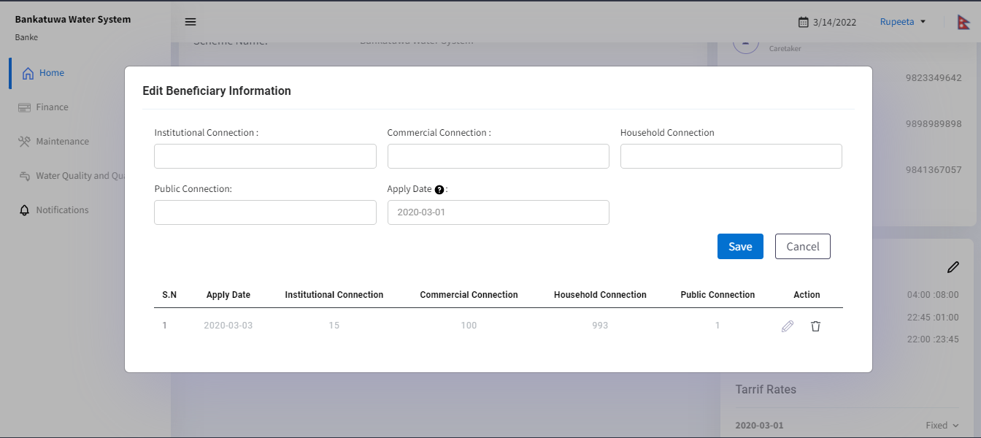

### 5.1.4 Tariff Rates

In the Tariff Rate Section, users can view different tariff rates by clicking on the fixed and user-based rates of Institution, Commercial, Households & Public for the respective years.

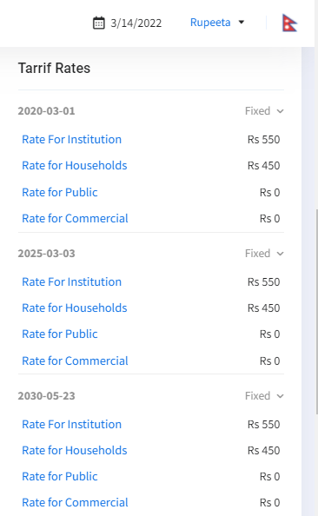

### 5.1.5 Add/ Edit Water Supply Schedule

In order to add Water Supply Schedule, the following details have to be filled in:

**You can select any time from morning to evening. It accepts the 24 hrs. format timings.**

1. Day: Add the name of Days (Example: SUN- WED) Day can be a single day ( like sun, mon, etc.) or day range ( like sun-mon, tue-fri, etc.). If there are multiple supplies in a single day, multiple entries need to be added.
2. Time From: Add the time from ( Example: 1:00).
3. Time To: Add the time to( Example: 20:00)
4. Comment: You can add specific comments on each water supply schedule if required.

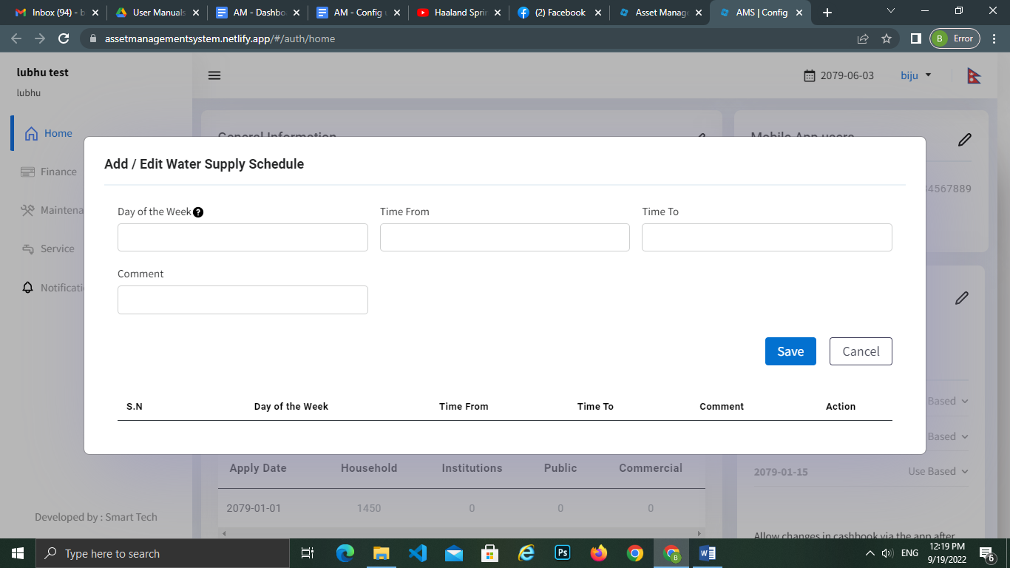

### 5.1.6 Allow changes in the cashbook via the app after the month is closed

There are two options available: Yes & No for disallowing app edit after month closing. This will affect the cashbook month closing while using the Mobile App. If admin users select yes, then he/she will be able to edit the cash book or can change the data after the month closes also. But if users select no, then he/she will not be able to edit the cash book or change any data after the month closes.

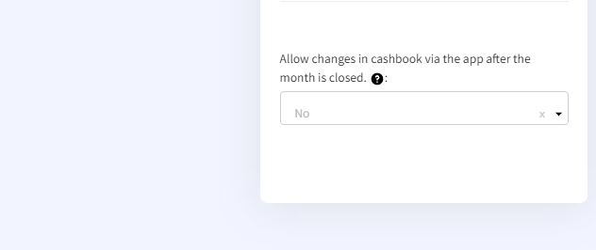

## 

## 

## 

## 5.2 Finance

In the Finance tab, there are mainly four sub-menus. Expected Income- Water Tariffs, Expected Income/Expenditures (Other), Inflation Rate(%), and Actual Income/Expenditure (Cash Book). In order to add these, the following details have to be filled:

### 5.2.1 Expected Income- Water Tariffs

There is the option to choose between two types of schemes. They are **fixed rate** and **use based.**

In fixed rate, the rate of water for specific connections is fixed regardless of the water used. Tariff rates for different time periods can be added using the different time periods. Year 1, Year 2, and so on can have different tariff rates on the basis of apply date.

In the used base, the rate of water is determined as per the amount of water consumption.

#### 5.2.1.1 Add/Edit Expected Income-Water Tariffs

In order to add **Fixed Based** Tariff Rates, the following details have to be filled:

1. Apply date: Add the date from which this record should be applied to the system.
2. Rate for Households): Add the water tariff rate for the households connection, use the previously selected currency
3. Rate for institutions: Add the water tariff rate for the institutional connection, use the previously selected currency
4. Rate for Public: Add the water tariff for the public connection, use the previously selected currency
5. Rate for Commercial: Add the water tariff for the commercial connection, use the previously selected currency
6. Estimated paying connection Households (%): Add the estimated paying connection Households in % (eg: 20%)
7. Estimated paying connection Institution(%): Add the estimated paying connection Institution in % (eg: 30%)
8. Estimated paying connection public(%): Add the estimated paying connection public in % (eg: 40%)
9. Estimated paying connection commercial(%): Add the estimated paying connection Commercial in % (eg: 10%)
10. Save the added data by clicking on the Save Button

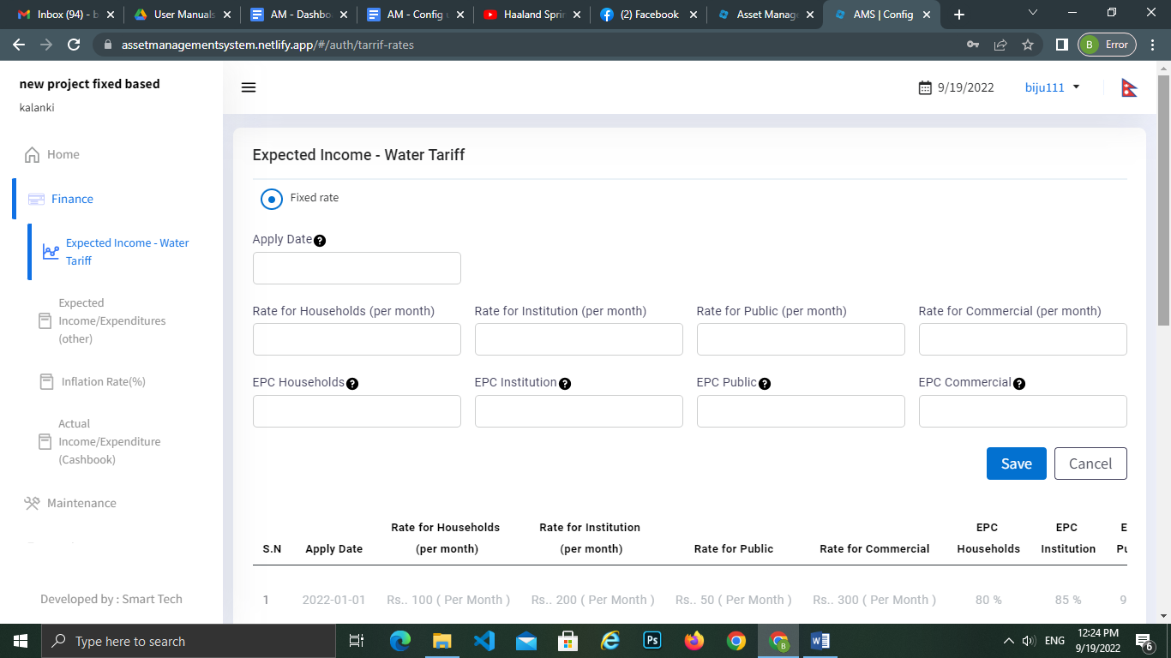

Users can view the graph in the configuration panel and other short information regarding tariff rates in the income estimates for the current year of water systems and also include other years as well.

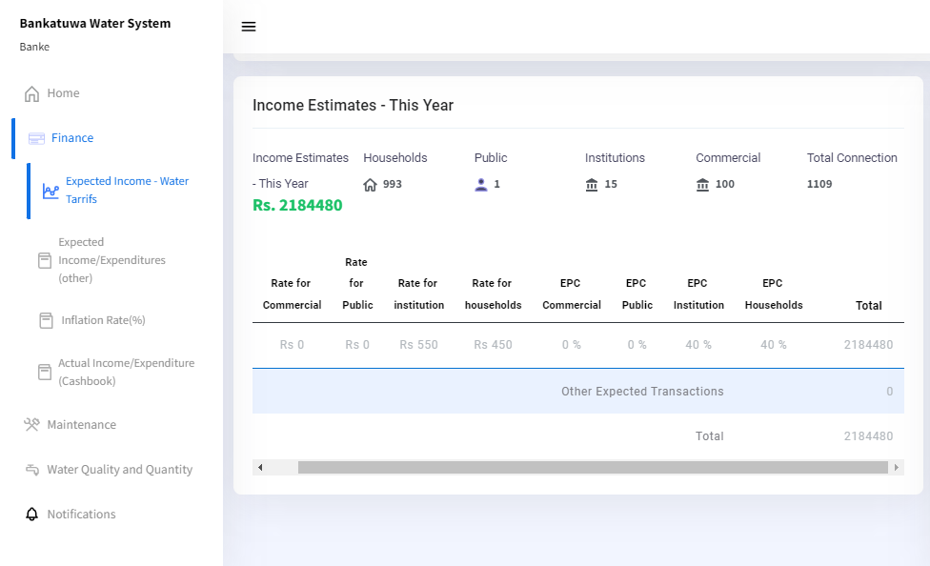

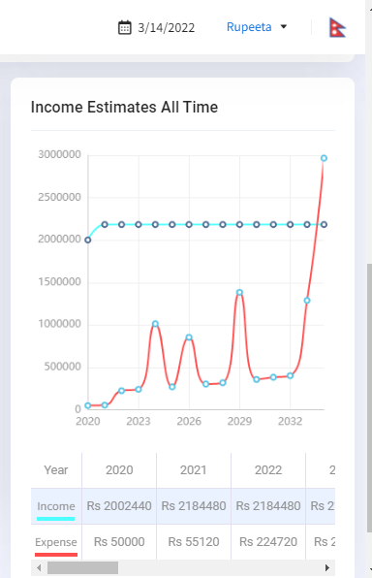

This graph refers to the Expected income and expenses. Therefore, if the expected tariff maintains the same the expected income will remain the same. Meaning that there is only one date, and one tariff introduced in the system.

#### 5.2.1.2 Add/Edit Expected Income-Water Tariffs

In order to add **Use Based** Tariff Rates, the following details have to be filled:

1. Apply date: Add the date from which this record should be applied to the system.
2. Unit starting from: Add the Unit (Example: 10)
3. Unit up to and including : Add the Unit (Example: 30)
4. Rate (per unit): Add the tariff rate for water units
5. EPC (%): Estimated Paying Connections is the estimated number of connections (represented in percentage) that will pay for the water service. Add the paying connection for water units (Example: 70%)
6. Save the added data by clicking on the Save Button

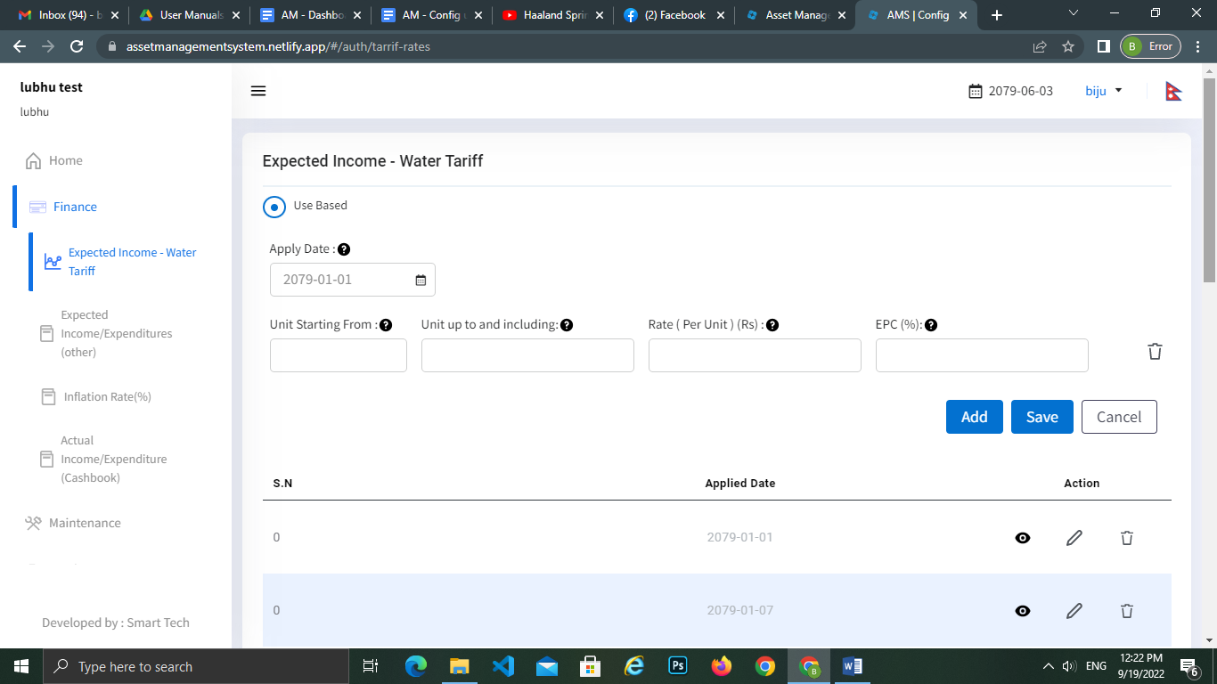

Users can view the graph and other short information regarding tariff rates in the income estimates for the current year of water systems and also including other years as well.

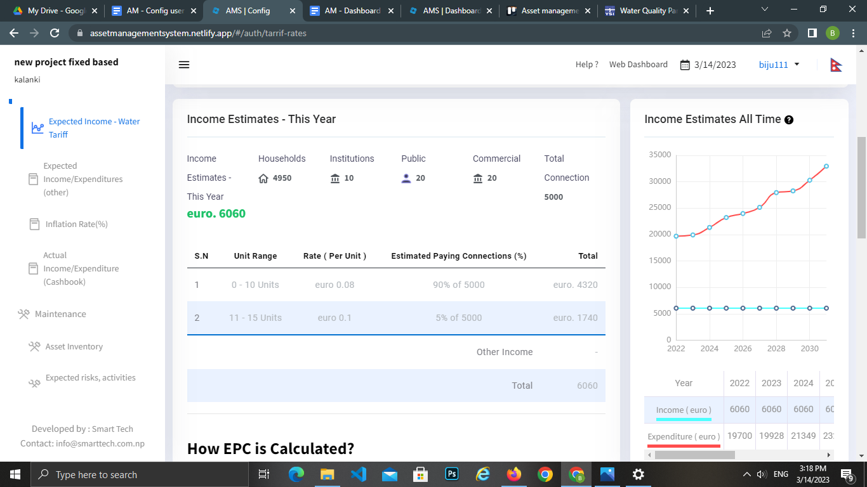

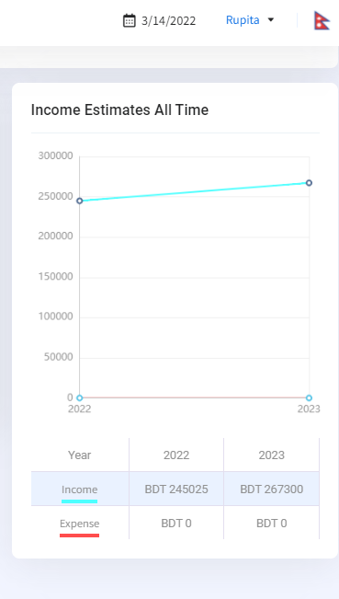

#### **`5.2.1.3 How EPC is calculated?**

EPC (Estimated Paying Connections) is the estimated number of connections (represented in percentage) that will pay for the water service. EPC assumes that all connections subscribed to the service may not make the payment due to various reasons. EPC varies per system and should be based on previous experiences from that system or surrounding systems. The following is just an example that will help to understand the concept of EPC better.

Let's assume there are different unit ranges, rates and EPCs as following:

There are two options for tariff collection in the system.

1. Fixed Rate  
   The cost is fixed for each beneficiary regardless of the use of water.

|  |  |  |  |
| --- | --- | --- | --- |
| **Beneficiary** | **Total Beneficiaries** | **EPC (%)** | **Description** |
| Household | 100 | 65% | Out of 100 connections, 65 households are expected to pay. |
| Institution | 20 | 80% | Out of 20 connections, 16 institutions are expected to pay. |
| Public | 10 | 70% | Out of 10 connections, 7 public beneficiaries are expected to pay. |
| Commercial | 5 | 80% | Out of 5 connections, 4 commercials are expected to pay. |

1. Used Base  
   The cost is variable according to the number of units of water used by the beneficiary. There is

always a minimum charge for the service regardless of the units used.

**Minimum Unit Charge:** All the beneficiaries are charged a minimum amount for usage of units up to a certain unit range. E.g. up to 10 units (0-10 units) cost is 125(currency), beneficiaries are charged (currency) 125 for use of water up to 10 units. This means that whether the beneficiaries have utilized water or not, they must pay the minimum amount after taking a water connection.

|  |  |  |  |
| --- | --- | --- | --- |
| **Unit Range** | **Percentage of Beneficiaries under unit rates** | **EPC** | **Description** |
| 0-10 (minimum unit) | Percentage of Beneficiaries under this unit rate:35% | 30% | Out of 140 connections, 49 beneficiaries are expected to use **ONLY** the minimum unit range. But in total, the remaining 20%, 30%, and 15% of the total users are also included under the minimum range during calculation. However, from the 49 beneficiaries that fall under this unit range, we can assume that only 42 will be paying the water tariff, the rest will not pay. Therefore, the EPC for this unit range is:(42/140)*100= 30% |
| 11-15 | Percentage of Beneficiaries under this unit rate: 20% | 15% | Out of 140 connections, 28(20%) beneficiaries are expected to use more than 10 units up to 15 units. From the 28 beneficiaries, only 21 will be paying the water tariff, the rest will not pay. In this case, the EPC can be calculated as: (21/140)*100=15%  The remaining 30% and 15% of the total users also fall under this unit range. |
| 16-20 | Percentage of Beneficiaries under this unit rate:30% | 25% | Out of 140 connections, 42(30%) beneficiaries are expected to use more than 15 units up to 20 units. From the 42 beneficiaries that fall under this unit range, only 35 will be paying the water tariff, the rest will not pay. For this case, the EPC can be calculated as: (35/140)*100=25%  The remaining 15% of the total users also fall under this unit range. |
| 21-30 | Percentage of Beneficiaries under this unit rate:15% | 10% | Out of 140 connections, 21(15%) beneficiaries are expected to use more than 20 units up to 30 units. From this 21 beneficiaries, only 14 will be paying the water tariff, the rest will not pay. The EPC can be calculated as: (14/140)*100=10% |
| **Total number of beneficiaries = 140** | **Users: 100%**  **EPCtotal: 80%** |  | ***Note*:**   1. **All unit ranges input should be within the total of 100% EPC as shown under Unit Range and EPC title and *should not exceed 100% in Total.***   ***EPC cannot exceed the percentage of beneficiaries under the selected unit rate.***   1. ***In Each unit range above the minimum unit range, beneficiaries under the mentioned range will be included in all the unit range below the particular unit range.*** |

**Calculation of Expected Income**

Calculation of Fixed Base:

|  |  |  |  |  |  |
| --- | --- | --- | --- | --- | --- |
| **Beneficiary** | **Total Beneficiaries** | **EPC (%)** | **Rate (Currency)** | **Number of months** | **Calculation** |
| Household | 100 | 65% | 120 | 12 | = 100 * (65%/100) * 120 * 12 |
| Institution | 20 | 80% | 140 | 12 | = 20 * (80%/100) * 140 * 12 |
| Public | 10 | 70% | 80 | 12 | = 10 * (70%/100) * 80 * 12 |
| Commercial | 5 | 80% | 160 | 12 | = 5 * (80%/100) * 160 * 12 |

Calculation of Used Base:

|  |  |  |  |  |
| --- | --- | --- | --- | --- |
| **Unit Range** | **EPC(%)** | **Rate (Currency)** | **Number of months** | **Calculation** |
| 0-10 (minimum unit) | 35% | 125 (minimum charge) | 12 | **=140*125*(35%/100)*12** |
| 11-15 | 20% | 25 | 12 | **=140*125*(20%/100)*12 + 140*25*(20%/100)*12*5**  *Here, 5 is the difference in unit range, there are 5 units if we calculate the units greater than 10 units up to 15 units.* |
| 16-20 | 30% | 35 | 12 | **=140*125*(30%/100)*12 + 140*25*(30%/100)*12*5 + 140 *35*(30%/100) *12*5** |
| 21-30 | 15% | 45 | 12 | **=140*125*(15%/100)*12 + 140*25*(15%/100)*12*10 + 140 *35*(15%/100) *12*10 + 140*45*(15%/100)*12*10**  *Here, every calculation is multiplied by 10 (max range difference and the highest range includes all the EPC below this range.* |
| **Total number of beneficiaries = 140** | **100%** |  |  | ***Note*:**   1. **140 = Total number of beneficiaries 125 = Minimum charge for every beneficiary must pay 12 = number of months % = EPC 5, 10 = Max unit difference taken for calculation** |

### 5.2.2 Expected Income/Expenditure (Other)

In order to add expected income/expenditure(Other), the following details have to be filled:

1. Apply Date: Add the date from which this record should be applied to the system.
2. Transaction Heading: Add the transaction heading.
3. Yearly Amount: Add the yearly amount for the transaction.
4. Transaction Type: Select either income or expenditure as per the transaction heading.
5. Apply for a specific date: Add “yes” if the transaction refers to a specific date or “No” and the transaction will be distributed evenly over all the months of the year
6. Repeats every year?: Add “yes” or “No” depending on whether the same expenditure/income repeats every year.

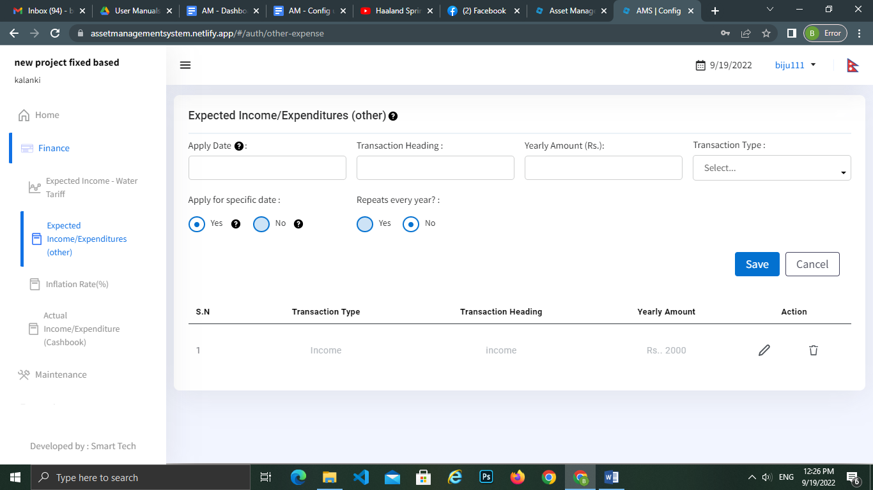

**Income/Expenditure Estimation of All Time:**

Expected income/expenditure is calculated on the basis of the prediction that the transaction will occur in the future.

Factors affecting the Expected income/expenditure

1. Expected income is calculated from the transactions that are under the Income categories, Expected Income/Expenditures (other), and the expected income from the water tariff rate used in Fixed and Use Based .
2. Expected expenditure is calculated from the transactions that are under the Expenditure categories, Expected Income/Expenditures (other), and Maintenance under Expected risks, activities and cost (Component Information).
3. First Year Calculation (assume the first year is 2022):  
   **Expected Income:** Rate applied in the Expected Income water tariff and the transactions in Expected Income/Expenditures (others) under the category Income are included.  
   **Expected Expenditure:** Transaction in Expected Income/Expenditure (others) under the category Expenditure and the expected maintenance cycle added from the Component Information. The inflation rate (if any) is applicable in the coming years,excluding the first year.  
   **Real Income** is calculated on the basis of real income under the Cash Book.  
   **Real Expenditure** is calculated on the basis of real expenditure under the Cash Book and the expenditures that occurred during the Maintenance Cycle.  
   *Note: See EPC Calculation for Expected Water Tariff*
4. Expected Income/Expenditure is affected by different factors that impact the calculation in the first year and the upcoming years (Visualize data for specified years): :
   1. Apply for specific date:  
      Yes: The transaction is applicable for the specified date only  
      No: The transaction is distributed evenly over all the months in the year.
   2. Repeats every year?  
      Yes: Specified transaction will repeat every year  
      No: Specified transaction will be applicable to either Apply Date (if chosen No for Specific Date) or Specific Date(if chosen Yes) and this transaction will not repeat in coming years.
   3. Matrix Representation of the factors affecting expected income/expenditure:

|  |  |  |
| --- | --- | --- |
| **Apply for specific date** | **Repeats every year?** | **Result** |
| Yes | Yes | The transaction is applied on a specific date and the same transaction will repeat in coming years on the same date. |
| Yes | No | The transaction is applied on a specific date only and will not repeat in the coming years. |
| No | Yes | The transaction is distributed evenly over all the months in the year and will repeat in the coming years evenly. |
| No | No | The transaction is distributed evenly over all the months in the year and will not repeat in the coming years. |

Fig. Matrix Representation

* 1. Expected income tariff rate applied in Used and Fixed Based makes a difference in the calculation if the Apply Date is different from the first year.
  2. Inflation rate (if applied) ensures an increase in the value of expected expenditures over the years. Not applicable in the first year.

### 5.2.3 Inflation Rate(%)

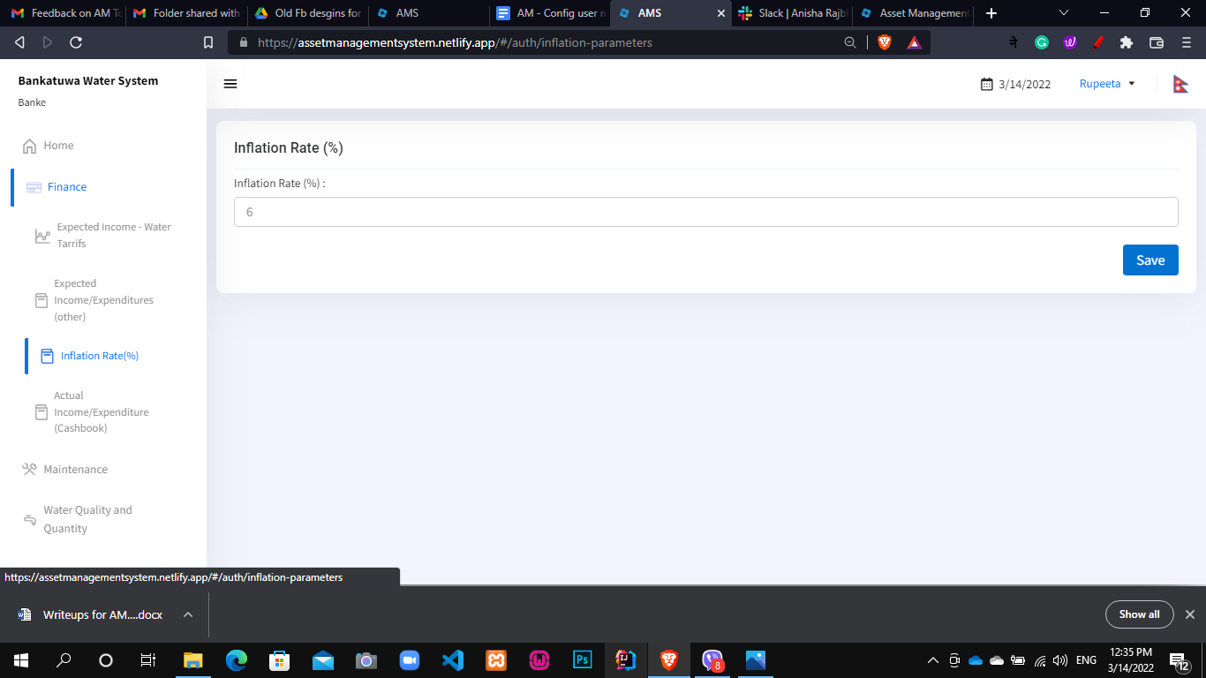

In order to add inflation Rate(%), the following details have to be filled:

1. Inflation(%): Add the country inflation rate (The inflation rate is applied only for expenditure and maintenance)

The future values of maintenence and expenditure can be determined by the following formula:

FV=PV(1+i)n-1

where, FV= Future value

PV= present value

i= inflation rate

n= no. of years

1. Save the added data by clicking on the Save Button

### 5.2.4 Actual Income/Expenditure (Cash Book)

In the actual income/expenditure (cash book) tab, there are mainly two sections, Income and Expenditure. There is also a date filter By Month & By Date in the right-up corner of the tab, where the user can select the date as per the date requirement in order to see income and expenses records for the given years.

These data can also be entered via mobile application.

By Month

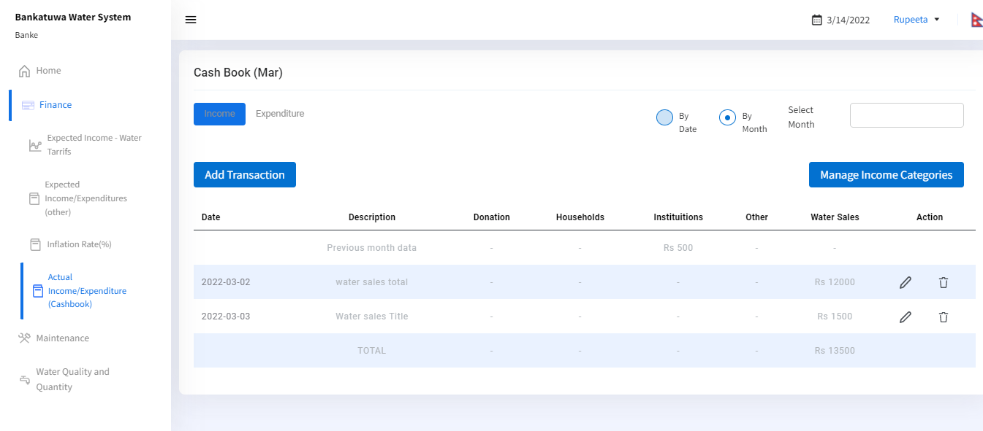

By Date

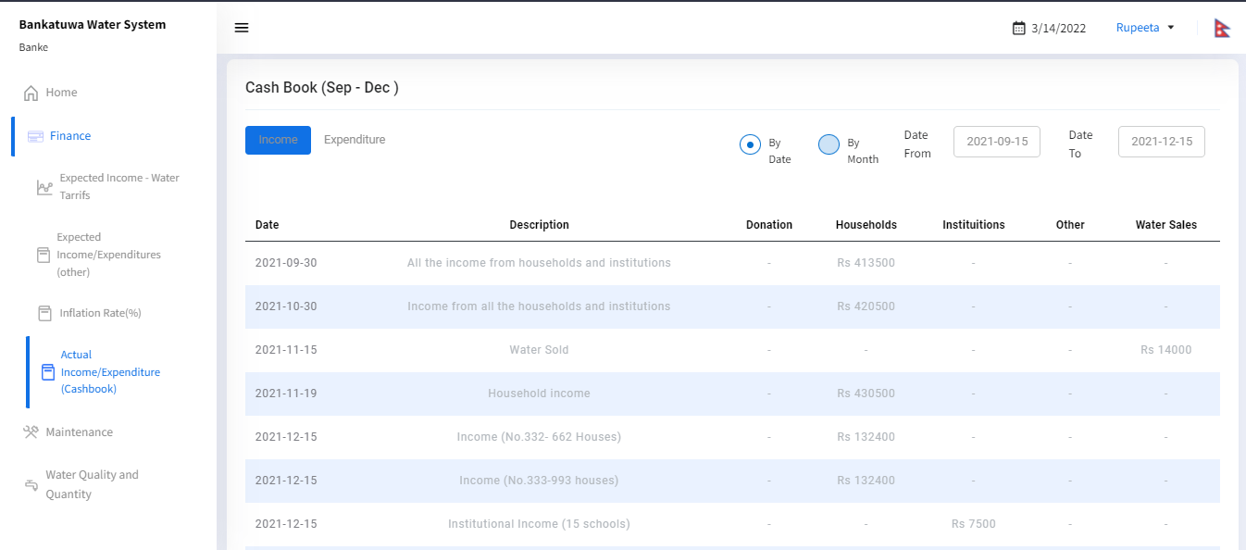

### 

#### 5.2.3.1 Manage Income Categories

In order to add income categories, the following details have to be filled:

1. Category Name: Add a category name for the Income. The categories added at this point are the same that will be available for the App users.
2. Save the added data by clicking on the Save Button.

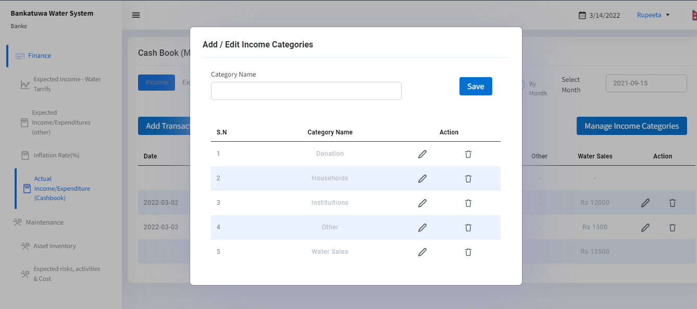

#### 5.2.3.2 Manage Expenditure Categories

In order to add expenditure categories, the following details have to be filled:

1. Category Name: Add a category name for the Expenditure. The categories added at this point are the same that will be available for the App users.
2. Save the added data by clicking on the Save Button

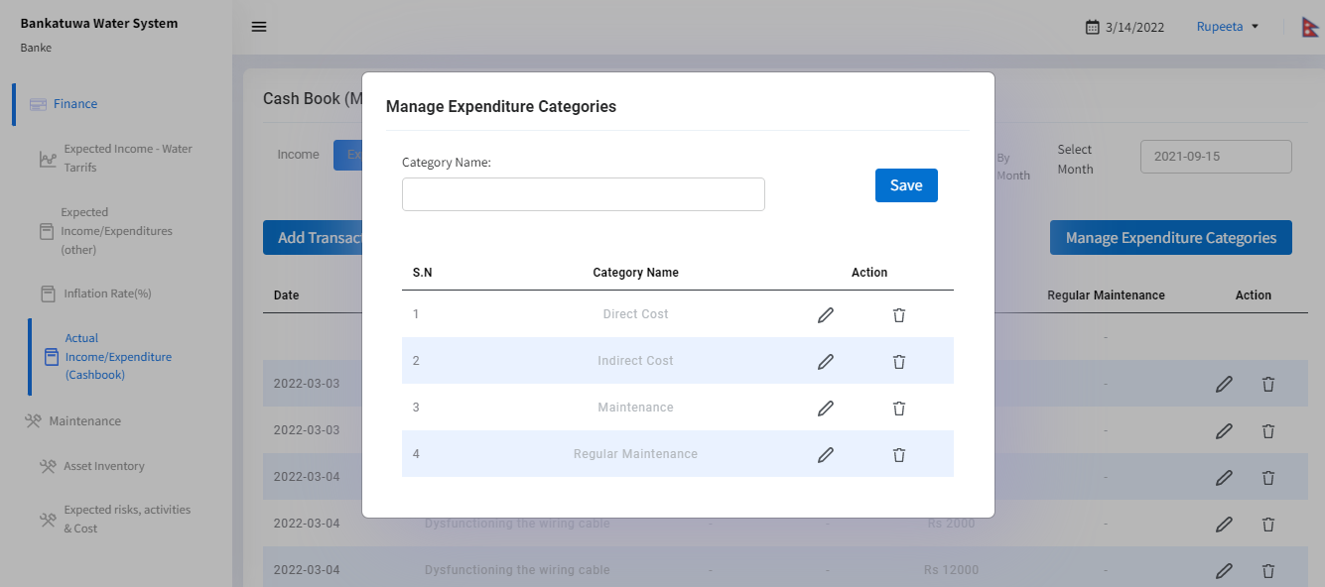

#### 

#### 

#### 5.2.3.3 Add/Edit Income

In order to add the income, the following details have to be filled:

1. Category: Select category from the given income category list
2. Date: Today’s date will come by default. If the user wants to change the date, it can be changed.
3. Title: Add the income title
4. Amount: Add the income amount
5. Water Supplied (Liters): Add the total water supplied for the month in Liters. This field will appear only after selecting the “Water Sales” category from the given categories.
6. Remarks: Add remarks for income title (optional)
7. Save the added data by clicking on the Save Button

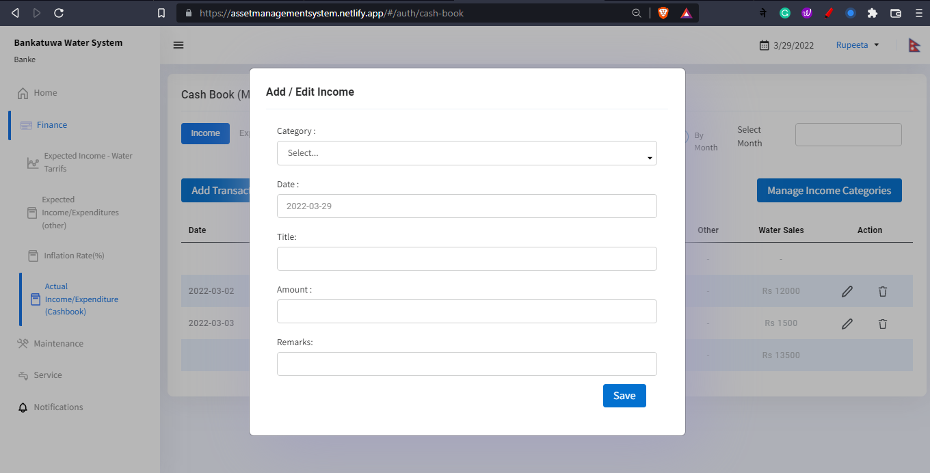

#### 

#### 5.2.3.4 Add/Edit Expenditure

In order to add the expenditure, the following details have to be filled:

1. Category: Select a category from the given expenditure category list
2. Date: By default, there will be a date (today’s date) for the expenditure. Users can change it if needed.
3. Title: Add the expenditure title
4. Amount: Add the expenditure amount. The option adding “cost separately” will be available there if the users select the “Maintenance” category from given categories. Then the segregated costs for the maintenance only can be added in the form of Labour, Consumables, or Replacement.   
   Consumable: is the expected cost of goods and repair costs required to fix machineries and other necessary equipment required for regular maintenance .  
   Labor: is the estimated cost of laborers required for maintenance.  
   Replacement: is the estimated cost of complete replacement of machines or equipment after their failure.
5. Remarks: Add the remarks for expenditure title (optional)
6. Save the added data by clicking on the Save Button

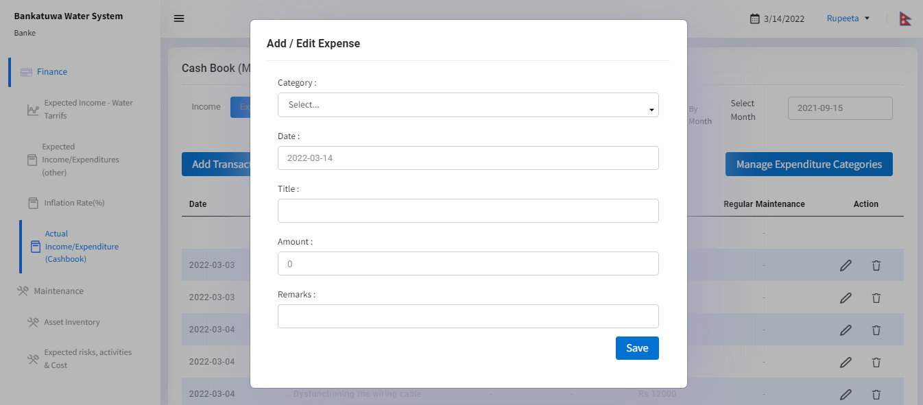

## 5.3 Maintenance

In the Maintenance tab, there are mainly three sub-tabs. These are Asset Inventory, Expected risk activities & cost, and Actual maintenance (Logs). In order to add the multiple data regarding this, the following details have to be filled:

### 

### 

### 5.3.1 Asset Inventory

#### 5.3.1.1 Add/Edit Asset Inventory (Component Categories)

In order to add the Asset Inventory, the following details have to be filled:

1. Title: Add the title of the component category
2. Save the added data by clicking on the Save Button.

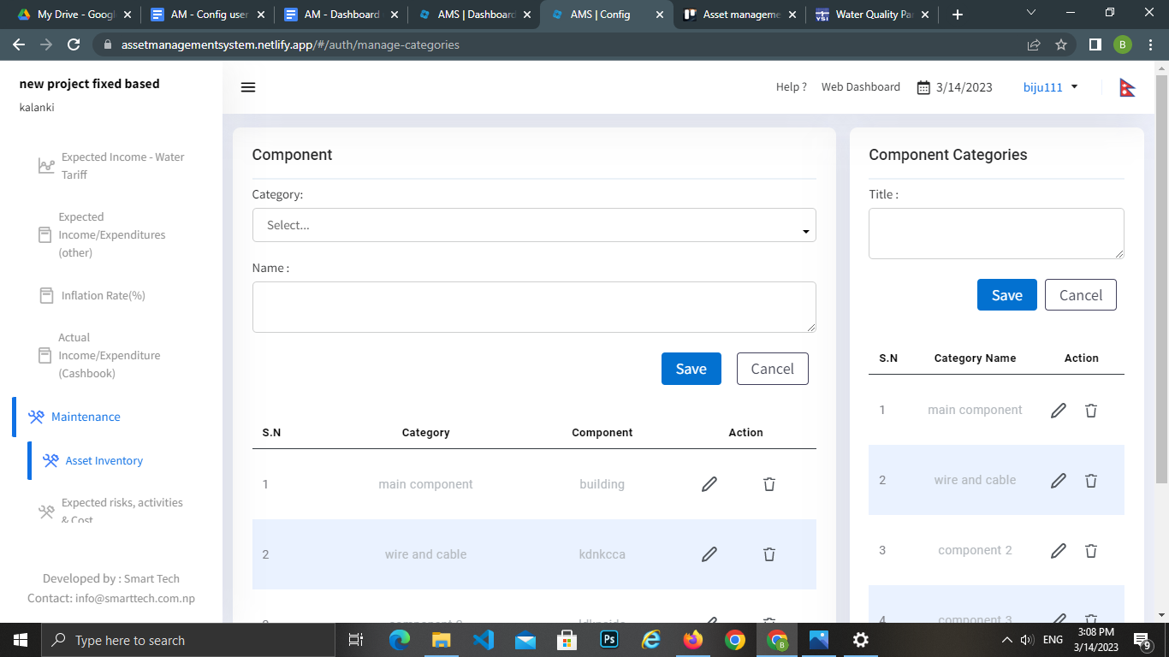

#### 

#### 5.3.1.2 Add/ Edit Component

In order to add the component, the following details have to be filled:

1. Category: Select category from the given Component category lists
2. Name: Add the component name
3. Save the added data by clicking on the Save Button.



### 5.3.2 Expected risks, activities & Cost

In order to add the information regarding asset components, the following details have to be filled:

#### 5.3.2.1 Add/Edit Component Info

In order to add component info, the following details have to be filled:

1. Component Name: Select the component name from the component list.
2. Component Number: Add the total number of components present in the system. It affects the calculation of costs. The number of components will be multiplied with either unsegregated costs or with individual labor, replacement, and/or consumable costs depending upon the data input.
3. Possible failure: Add the possible failure of the component category selected previously
4. Maintenance action: Add the maintenance action required for the component category
5. Maintenance Interval: Add the maintenance interval of the component. Year/Month/Days can be selected from the dropdown list. Maintenance action needs to be repeated after the every selected time duration. If the maintenance action needs to be done before the predefined maintenance interval, the interval can be edited in the “Add/edit component Info” section.
6. Executed Maintenance cost: Add total maintenance cost without any segregation. If the user wants to add the segregated cost for maintenance, he/she needs to click on the add cost separately check box.

* Labor cost : Refers to the labor costs for providing a one-time maintenance/repair to the system component.
* Consumable Cost: Refers to all materials costs for a one-time maintenance/repair to the system component.
* Replacement Cost: Add the total costs of completely replacing the system component (so both labor & material costs).

**NOTE:** The same component should be added twice if it has both repair and replacement needs. E.g., Valve needs to be replaced once every 5 years. Then you should add the component and include replacement costs and keep Labour and Consumable costs at 0 (zero). Valve also needs lubrication every 3 months. Then you should add the same component again and insert the Labour and Consumable costs of that, but keep Replacement cost at 0 (zero).

1. Likeliness of Failure: Select one of the likeliness of failure from the given list
2. Impact of Failure: Select one of the impacts of failure from the given lists.
3. Mitigation: Here, mitigation refers to the types of action that needs to be done to regarding the failure of the component. Select one of the mitigation from the given lists

* Reactive: One reacts when the asset breaks down or fails.
* Inspection: One uses regular pre-planned inspections to determine the state of the assets, and plan maintenance based on that.
* Preventive: One does maintenance when a certain specified parameter reaches a certain value/level (e.g. replacement of a valve after 10,000 liters or water supplied).

1. Designated Person: Write the name of the designated person, responsible for maintenance of the component used in the system.
2. Apply Date: The date from which this record should be applied to the system.
3. Next Planned Action date: The date on which the next maintenance action is scheduled. Leave the field empty if the next planned action date is not applicable.
4. Next Planned Action Date: The date that is decided for the maintenance of a particular component. The caretaker adds this date to the component if/when he/she has determined the exact date for maintenance of the component. Until added manually the system records the first date of its next maintenance period as the action date.
5. Component picture: Add the component picture which should be less than 10Mb.
6. Save the added data by clicking on the Save Button.

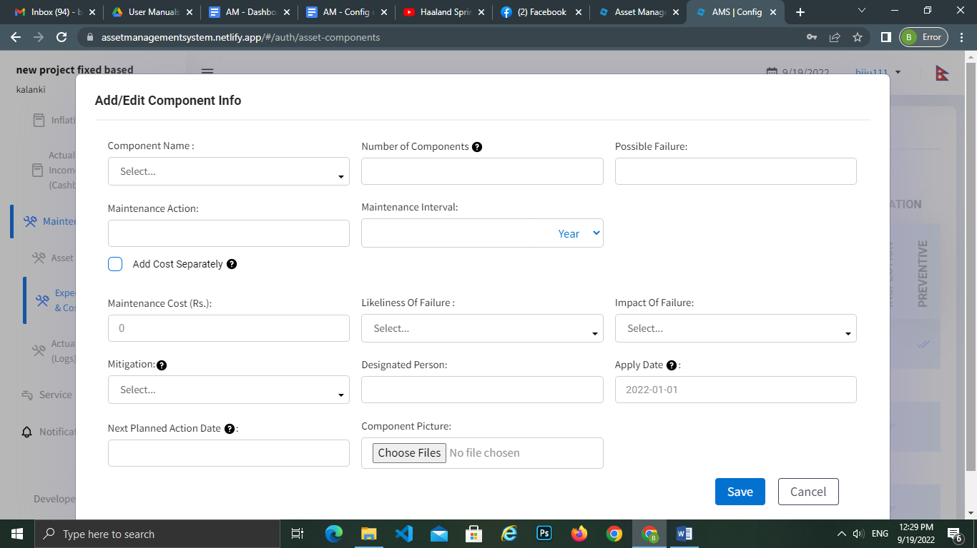

#### 5.3.2.2 Add/ Edit Issue (Logs)

In order to add the Issue logs, the following details have to be filled:

1. Component: Select the component category from the given lists
2. Issue date: Add the Issue date for the component category
3. Cause of failure: Add the cause of failure of the component
4. Maintenance Action Proposed: Add the maintenance action proposed for the component to solve the problem
5. Time required: Add the interval in days/months/year on which the maintenance action should be taken of the component in order add the log (interval in days/month/year)
6. Total Cost: Add the total cost of the component (without any segregation cost)

For segregated cost, see point 5.3.2.1 of this manual:

Add:

Labor cost: Add the labor cost (if there is segregation of the cost)

Consumable Cost: Add the material cost (if there is segregation of the cost)

Replacement Cost: Add the replacement cost (if there is segregation of the cost)

1. Log status: Mark Resolved or Unresolved, depending on whether the issue has been solved or not
2. Remarks: Add the remarks for the component (optional)
3. Component Picture: Component Picture will be shown here if the users have added image(s) from the mobile app only .
4. Save the added data by clicking on the Save Button.

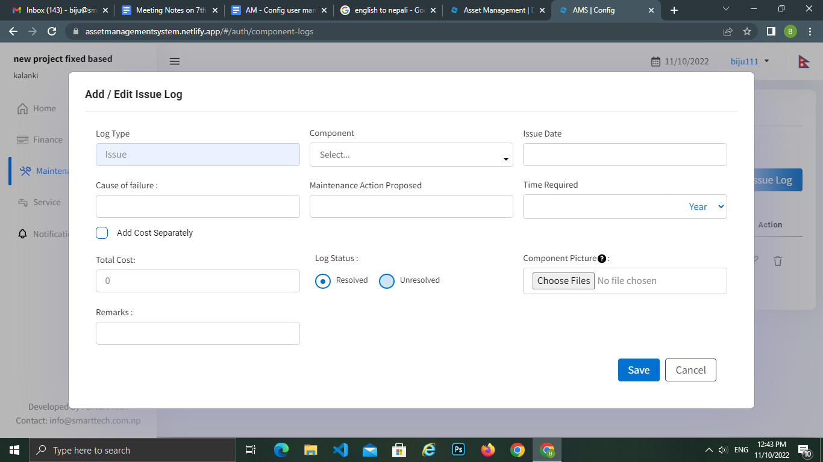

#### 5.3.2.3 Add/ Edit Actual Maintenance Logs

In order to add the Maintenance log, the following details have to be filled:

1. Component: Select the component category from the given lists
2. Maintenance date: Add the maintenance date for the component category
3. Cause of failure: Add the possible cause failure of the component
4. Maintenance Action Executed: Add the last maintenance action executed for the component
5. Time required: Add the interval on which the maintenance action was performed (it can be days/month/year).
6. Total Cost: Add the total cost of the component (without any segregation cost)

For segregated cost, see point 5.3.2.1 of this manual:

Add:

Labor cost: Add the labor cost (if there is segregation of the cost)

Consumable Cost: Add the material cost (if there is segregation of the cost)

Replacement Cost: Add the replacement cost (if there is segregation of the cost)

1. Remarks: Add the remarks for the component
2. Component Picture: Component Picture will be shown here if the users have added image(s) from the mobile app only .
3. Save the added data by clicking on the Save Button.

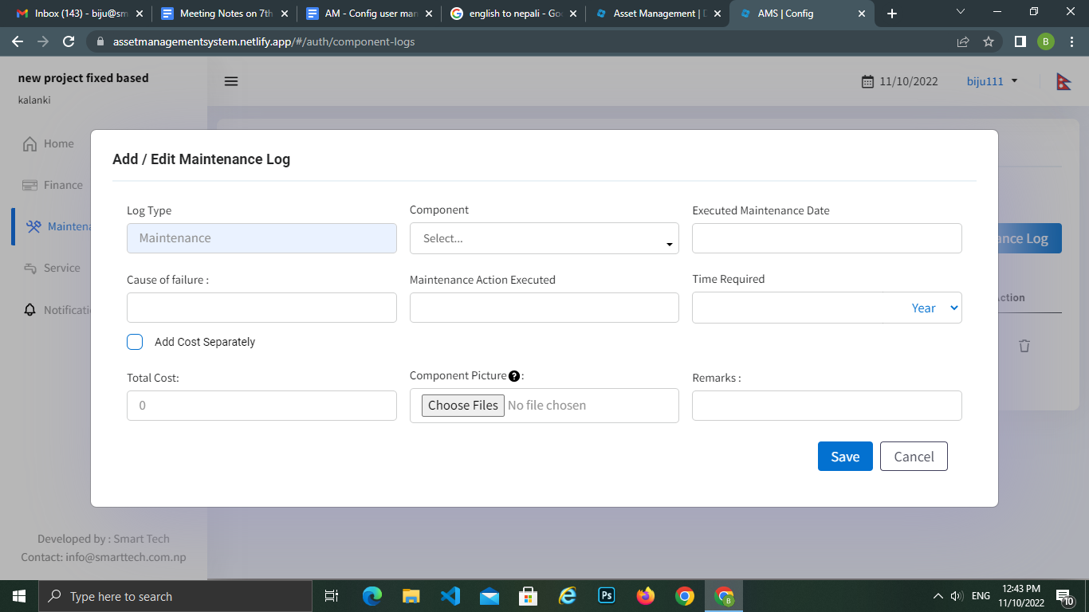

Note: these maintenance logs are not visual in the web-dashboard, but the entered costs while recording these logs are the actual maintenance cost. These costs are added to the expenses in financial visualization of the dashboard. They are also recorded as actual maintenance expenses in the cash book. They are also visualized as the actual maintenance cost in the maintenance visualization.

## 

## 5.4 Service

In the Service tab, there are two sub-tabs. They are the Water Supply Record & Water Quality Test. In order to the multiple data regarding this, the following details have to be filled:

### 

### 

### 5.4.1 Water Supply Records

#### 5.4.1.1 Add/ Edit Water Supply Record

All the water supply records that are saved via the mobile app will be available here to edit. There is also scope to add Water Supply Records directly from the configuration panel. In order to add and edit the Water Supply Records, the following details have to be filled in:

1. Total Daily Supply (liters): Add the total water supply in liters from the main distribution point of the water system.
2. Supply Date: Add a calendar date to record the water supply. Users can also add date range by clicking on the “Add Supply End Date” checkbox.

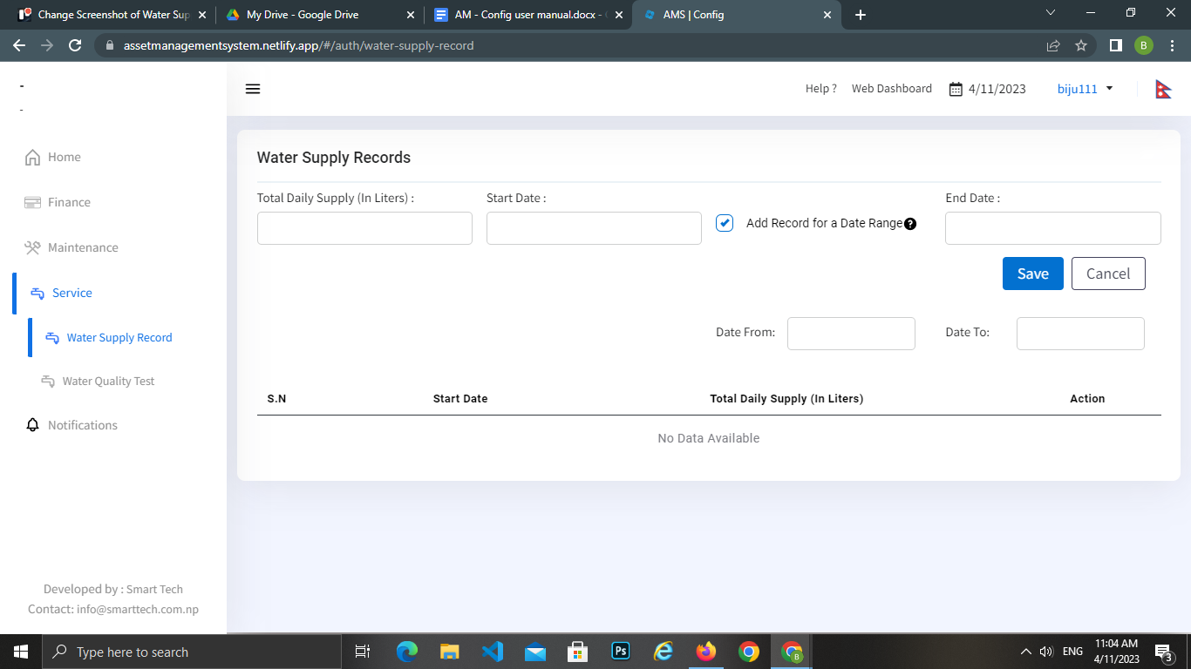

### 5.4.2 Water Quality Test

In order to add the water quality test, there are two tabs: Quality Test Parameters & Water Test Result on the same page.

#### 5.4.2.1 Add/ Edit Quality Test Parameter

Water quality parameters are the chemical, physical, biological and other properties that can be tested or monitored to determine the actual water quality.

In order to add the water quality test parameter, the following details have to be filled:

1. Parameter name: Add the parameter name for the water quality test (e.g. Turbidity, residual coliform, pH, Iron)
2. Unit: Add the unit of the quality test parameter
3. National Drinking Water Quality (NDWQ) Standard: Add the given NDWQ Standard for the water quality test parameter. It is the quality standard for drinking water. It will be displayed in visualization in the dashboard.
4. Types: Select the types, either chemical, physical or other from the lists.
5. Save the added data by clicking on the Save Button.

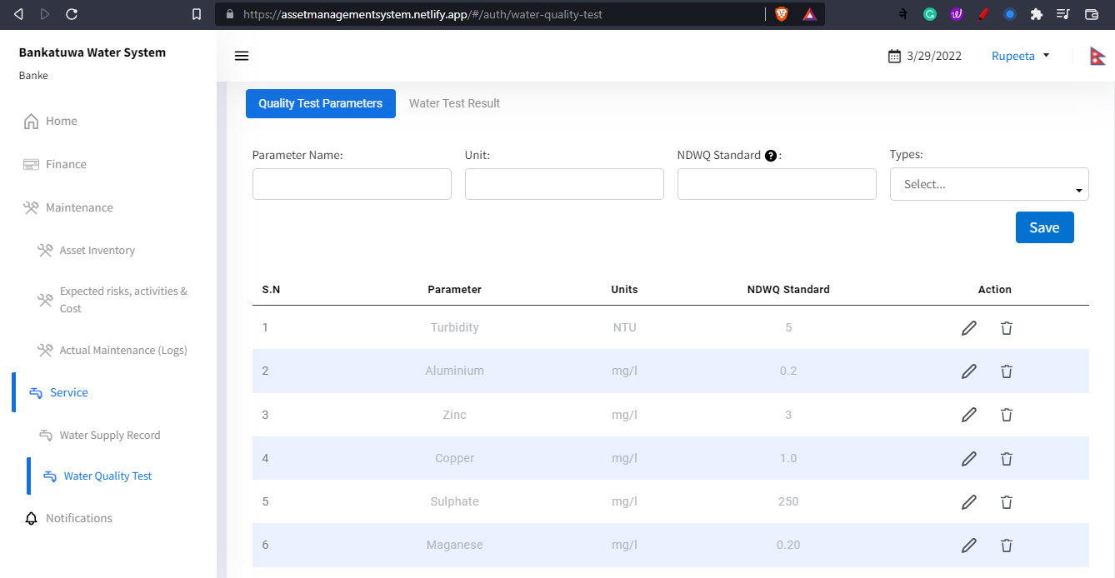

#### 5.4.2.2 Add/ Edit Water Test Results

All the water test results that are filled & saved via the mobile app will be available here to edit. There is also scope to add Water Test Results directly from the configuration panel. In order to add and edit the water test results, the following details have to be filled in:

1. Start Date: Add a calendar date to record the water test result

There is an option to add the test result record for a particular date range. This can be done by clicking the checkbox which then shows the field to add the end date.

1. End Date: It is the date up to which the test results will be added.

The parameters entered in the Quality Test Parameter will show here.

Users can add and edit the water test result as per the given water test parameters respective to their units.

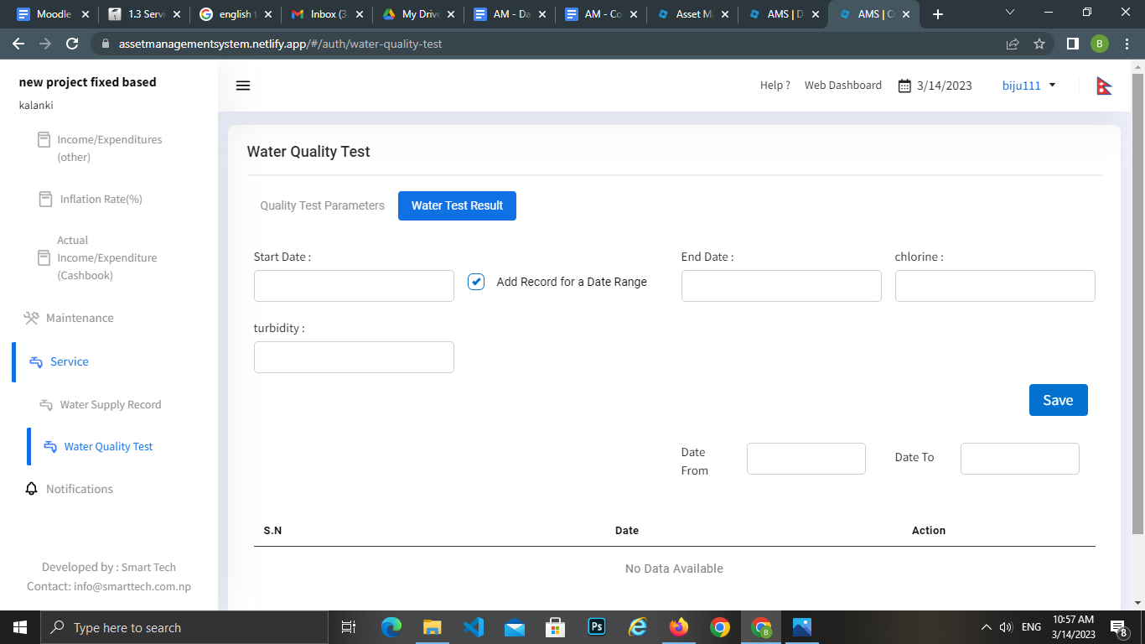

## 5.5 Notifications

On the left side of the configuration panel , there is a tab named ‘Notifications’. All the notifications visible on top of the mobile app are managed from this section. Users can manage their notifications by adding the date with the specific time period for income notification, expenditure notification, test result notification, supply record notification and when to do maintenance notification, so that the mobile app user can be notified on time.

### 5.5.1 Manage Notifications

All the notification intervals should be input in the number of days. If one does not want a notification for any specific event, the field(s) should be filled with 0. The notification of the event that will occur or has occurred will be displayed on the Mobile Device before or after the days specified for the event to occur. All the notifications will be displayed before the specified days’ interval if otherwise mentioned. For example, if the notification interval is filled for 7 days, the notification will be shown for a single time 7 days before the occurrence of the particular event.

In the case of Maintenance, if the maintenance has been done on a specified date, the notification will stop showing. But if the maintenance has not been done by the specified date, the notification will be displayed repeatedly after the number of days in the same interval of days specified in Maintenance Notify After from the maintenance date.

In order to manage notifications, the following details have to be filled:

1. Initial date: The date for the notification function to start taking effect.
2. Income notifications period (in days): The number of days or days interval in which the user should be notified to add income records.
3. Expenditure notifications period: The number of days or days interval in which the user should be notified to add expenditure records.
4. Test result notifications period: The number of days or days interval in which the user should be notified to add quality test records.
5. Supply record notifications period: The number of days or days interval in which the user should be notified to add water supply records.
6. Maintenance Notify Before: The number of days or days interval before any maintenance action date in which the user should be notified of the upcoming maintenance action.
7. Maintenance Notify After: The number of days or days interval after any maintenance action date in which the user should be notified of the maintenance action that is not logged. If a log is saved for the maintenance action, this notification will not be sent.
8. Save the added data by clicking on the Save Button.

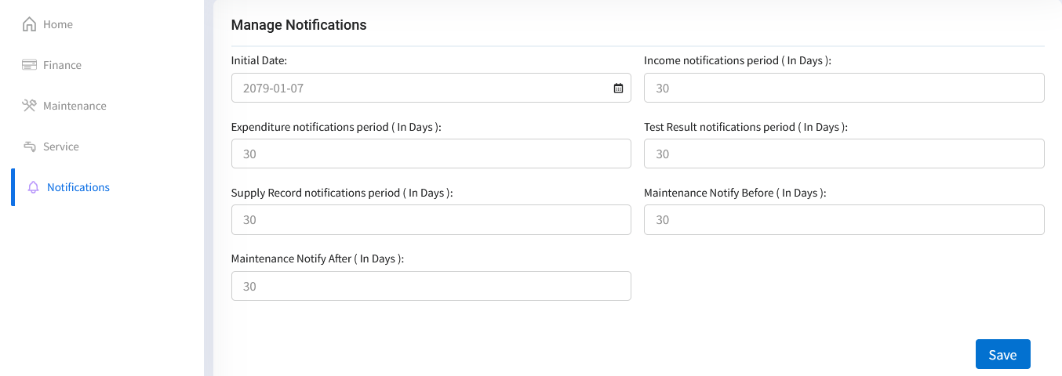

Note: Enter 0 as the value if you do not want notification of any particular type.

## 5.6 Change Language

There is an availability of two languages: English and Nepali. Users can select the language by:

1. Clicking on the top right corner in the configuration panel, where there is an Icon of Flag.

## 5.7 Logout

Users can logout from the web configuration by:

1. Clicking on the user name placed on the top right corner of the configuration panel (near the language selection Flag Icon) and then clicking on the Logout displayed text.

For any further information, please contact to the email address below:

Email: [info@smarttech.com.np](mailto:info@smarttech.com.np)

**Thank you**